TREND OF SENTIMENTS ON TWITTER
Susmitha Madishetti
Graduate Student
Department of Computer Science
State University of New York, Albany
Email:- smadishetti@albany.edu
Phone: +1 5516662474

Abstract- Social media pages play an important part in a business ' growth as it has emerged as one of the tools to boost the views of customers and impact the company. People's opinion on social networking websites such as Twitter is indeed very valuable to analyze how lives is impacted by the propagation of information. Sentiment analysis of the tweets determine the polarity and inclination of vast population towards specific topic, item or entity. During government polls, film reviews, and many other areas, applications of such assessment can be easily and efficiently noted these days. We have studied the different methods in this venture to obtain live tweets and analyze feelings. The main goal is to provide a technique in loud twitter flows to analyze sentiment rating. This document notes on the layout of the assessment of feeling, extracting a large amount of tweets. Results classify Positive and negative tweets in the view of the user through tweets. Secondly, we address in detail and incorporated with the internet implementation multiple methods for carrying out sentiment assessment on twitter information.
Terms — Sentiment Analysis, Twitter, Opinion mining, Integration with web.

Introduction(motivation,problem statement,significanceof the prob)
As time progresses, various social media platforms are developing and becoming an influential means of interaction Social media and micro-blogging platforms like Facebook, Twitter, and Tumblr dominate the quick spread of encapsulated news and trend topics across the world.

Motivation: If many users contribute more of their perspectives and judgment on a particular subject, it becomes a trending subject, making it a valuable source of view. In general, they are intended to generate awareness or promote government leaders, political campaigns during elections, brand endorsements and entertainment such as movies award shows. Generally, major corporations and firms take advantage of the opinion of individuals to enhance the goods and services they provide and constantly enhance advertising policies. One such example is the leakage of fresh devices or fresh technology to generate a hype to capture the feelings of people and sell the item before it is released. Thus, there is enormous potential to discover and analyze exciting trends for business-driven apps from endless social media information.

Problem Statement: Analysis of sentiment is the forecast of feelings in a phrase or a text phrase. It is meant to act as an instrument for understanding the behaviors, views and feelings expressed in an internet reference. The purpose behind certain subjects is to obtain a summary of the broader government view. Sentiment analysis is the prediction of emotions in a sentence or text sentence. It is intended to behave as a tool to understand the habits, opinions and emotions expressed in an online reference. The aim behind some topics is to get an overview of the wider perspective of governance Analysis of sentiment is the forecast of feelings in a phrase or text. It aims to act as an instrument for understanding the practices, views and feelings expressed in an internet reference. The goal behind some subjects is to gain an outline of the broader management view. Sentiment analysis is the prediction of emotions in a sentence or text. It seeks to behave as a tool for knowing web reference methods, opinions and emotions. The objective behind some topics is to obtain an overview of the wider perspective of leadership. Analysis of sentiment is the forecast of feelings in a phrase or text. It aims to act as an instrument to know techniques, views and feelings of internet reference. The goal behind some subjects is to get an outline of the broader management view. The personality restriction therefore enforces the use of hashtags to classify content. Roughly 6,500 tweets are currently being released per second, resulting in around 561.6 million tweets a day. Generally speaking, these flows of tweets reflect multiple topics, altering data about behaviors in unfiltered and unstructured format. Analysis of Twitter sentiment includes the use of natural linguistic processing to collect, recognize in order to characterize the material of feeling. In terms of tonality, polarity, lexicon and tweet grammar, there are many challenges involved. They tend to be extremely unstructured and unstructured. Interpreting their significance becomes hard. In addition, when tweeting internet, comprehensive use of slang phrases, acronyms and vocabulary phrases is quite prevalent. The categorization of such words per polarity gets tough for natural processors involved.
In Section II, we detailed some related work of our project by highlighting important features. Next, Section III gives brief details about the technologies used. Section IV cover details of methodology & implementation of the project. The problems we came across and the challenges we resolved during implementation are specified in section V. Further, in Section VI, future work is discussed. Finally, Section VII concludes the report

literature Review

This chapter summarizes some of the studies and academic work in the field of machine learning and information mining to evaluate Twitter feelings and prepare model forecast for different apps. As the social platforms accessible are speeding up, the data becomes extensive and can be obtained to transform it into company goals, social activities, advertising and other promotional policies as described below. Authors in consider the benefit of social media in knowing government opinion and extracting their feelings and explaining how twitter provides political advantage during campaigns. In addition, the hashtag idea is used to classify writing as it conveys emotion in just a few phrases. They proposed how earlier study work endured from absence of practice and missed certain characteristics of destination information. They chose for a two-stage strategy to their framework — first preparing twitter coaching information using mining to convey appropriate characteristics and then proposing the Supervised Learning Model to forecast the outcomes of the 2016 U.S. election. Following the collection and pre-processing of the tweets, teaching information collection was developed first by manual hashtag labeling and cluster forming, then by using internet Sentimental Analyzer VADER which produces the ratio polarity. This strategy decreased the amount of tweets or practice sets and also implemented the classification algorithm Support Vector Machine and Naive Bayes to determine the tweet polarity. Multi-stage classification strategy where an organization classifier gets overall class of tweets and categorizes them for contrast with individual applicants. The measure used to determine the recipient was the "PvT proportion," which is the positive amount of tweets for the alternate applicant to the full amount of tweets. Researchers ' Sentiment Analysis Imran et al.[1] used the' Apache Spark ' technique for quick tweet streaming and described the StreamSensing strategy for handling real-time information in unstructured and loud type. They performed the twitter information strategy to discover some helpful and exciting patterns that can also be extended to any flow of real-time text. Uncontrolled teaching method is used to find exciting models and trends from Apache Spark-processed tweets. The prevalent strategy discovered in nearly all appropriate study projects is the compilation of information using Twitter API, pre-processing of information, processing of information and then methods in the production of features, classification and model assessment. The topic of trending or hashtag is provided and suitable tweets are edited to generate TDM and the primary idea of this sensation evaluation is to calculate the weights of TF-IDF to find the most important sentences. One of the illustrating characteristics of this study job is parallel computing of TDM, TF-IDF rating and determination of top 5 keywords produced from TDM in each minute as sliding window transitions. It thus leverages Apache Spark's quick computing capacity. In another work of Sentiment Analysis and Influence Tracking on Twitter, authors also predicted the polarity – positive, negative or neutral of tweets by creating a classifier. In addition, they used multiple algorithms and methods to determine the influence of active entity on the tweet patterns of users exhibiting certain emotions. Only at the point of the organization, i.e. brand, product, personality aspects current in tweets, they mined tweets rather than the whole phrase in user published tweets. The strategy they used to obtain characteristics using algorithms and monitor the effect and influence rendered their job distinct from the remainder of the literature. After preprocessing, the function removal method included building n grams together with POS taggers taking care of the negation portion and enhancing classification precision. More the value of People Rank is the primary concept behind this algorithm, the more key the node in the chart implies its significance on facebook in terms of supporters, retweets and references. The other algorithm is the Twitter Rank algorithm, an addition to website Rank to determine user impact by considering user resemblance and node composition, i.e. other consumers to whom they are connected. They discussed Page Rank's deficiencies and created this strategy. The strategy they are proposing has the ability to determine personality / entity impact on facebook and can be used for advertising and marketing reasons.

Proposed method
Trend of Sentiments on Twitter will be a user-friendly software for evaluation in which users can search for any keyword to discover the changes for real-time in tweets on Facebook. We would like to use bigram in this initiative to improve the connection between the information and provide more precise outcomes of feeling assessment. The representation of the results will be user friendly so that user can get an easy interface to interact and view trend of sentiments on searched topic.

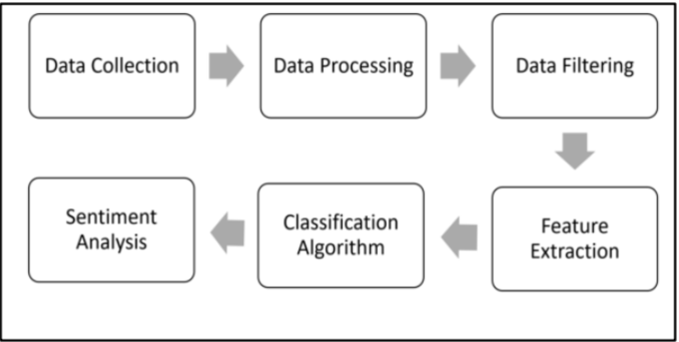
Stage 1. Data Collection
Data in the form of raw tweets is retrieved by using the twitter API which provides a package for real time twitter streaming API. The API requires us to register a developer account with Twitter and fill in parameters such as consumerKey, consumerSecret, accessTokenaccess, and TokenSecret. This API enables the use of keywords to obtain all random tweets or filter information. Filters promote the retrieval of tweets that suit the developer's particular criteria. We used this to get tweets linked to particular keywords removed from customers as feedback. Initially, we put at least the title and mode of the implementation. Instead of clustering, we run the program in local mode. For example, on inputting multiple keywords like, 'Mexico', 'Trump', 'Toronto', the output we obtained from 15 seconds’ window time was the live stream of tweets associated with these keywords. Only caveat of using filters is that famous keywords like “India” have more tweets compared to niche words like “Focusrite” which makes it difficult to get data for niche specific keywords.
Stage 2. Data Processing
Data processing involves Tokenization which is the process of splitting the tweets into individual words called tokens. Tokens can be split using whitespace or punctuation characters. It can be unigram or bigram depending on the classification model used. The word bag system is one of the most widely used classification system. It is focused on assuming that writing is categorized as a pocket or set of individual phrases without any connection or interdependence. Using unigrams as characteristics is the easiest way to integrate this template into our project. It's just a set of individual phrases to be categorized in the message, so we use white space to divide each tweet. For example, the tweet “No Building Wall Trump” is split from each whitespace as follows. {“No Building Wall Trump!!”}. The next step in data processing is normalization by conversion of tweet into lowercase. Tweets are normalized by converting it to lowercase which makes its comparison with a dictionary easier.
Stage 3. Data Filtering
After data handling, a tweet obtained still contains a part of raw information that we may or may not discover helpful for our implementation. Thus, these tweets are further filtered by removing stop words, numbers and punctuations. Stop words: For example, tweets contain stop words which are extremely common words like “is”, “am”, “are” and holds no additional information. These phrases do not serve any objective and use a list stored in stopfile.dat to implement this function. We then compare with this list each term in a tweet and delete the phrases that match the stop words removal. Removing non-alphabetical characters: Symbols such as “#@” and numbers hold no relevance in case of sentiment analysis and are removed using pattern matching. Regular expressions are used to match alphabetical characters only and rest are ignored.
Stage 4. Sentiment Analysis
As described in above Stages data collection, processing and filtering for any machine learning algorithm to yield best results. Authors collected data for two different topics namely Politics and Food and trained the classifier using Support Vector Machine where model is trained such that when user entered new keyword for these two topics, model with perform as it did for training data.
Support Vector Machine (SVM)
Support Vector Machine (SVM) is a supervised machine learning algorithm which is used for classification problems. In SVM data item as a point in n-dimensional space (where n is number of features you have) with the value of each feature being the value of a particular coordinate [6]. Then, we perform classification by finding the line (or hyperplane) that differentiate the two classes to distinguish such that each data item belong to one of the two classes.
SVM is a kernel method algorithm which depends on the data only through dot-products. While in case of SVM, the dot product can be replaced by a kernel function which computes a dot product in high-dimensional feature space[1].

Linear Classifiers
For this project, we have implemented Support Vector Machine Linear Classifiers. Linear Classifier data for a two-class learning problem consist of objects labeled with one of two labels corresponding to the two classes; for this project we labeled the data as 1 (positive) or 0 (negative)

Support Vector
Support vectors are the data points that lie closest to the decision surface (or hyperplane) this hyperplane is equidistant from both the classes. The data instances which are used to define this hyperplane are known as support vector. A margin is defined in SVM which is the distance between hyperplane and the nearest support vector. For good separation by this hyperplane, the distance of margin should be as large as possible because large distance gives less error. If the margin is close then it is more sensitive to noise [4].

A key concept required for defining a linear classifier is the dot product between two vectors, also referred to as an inner product or scalar product. Support vectors are the elements of the training data set that would change the position of the dividing hyperplane if removed.(cite 3)

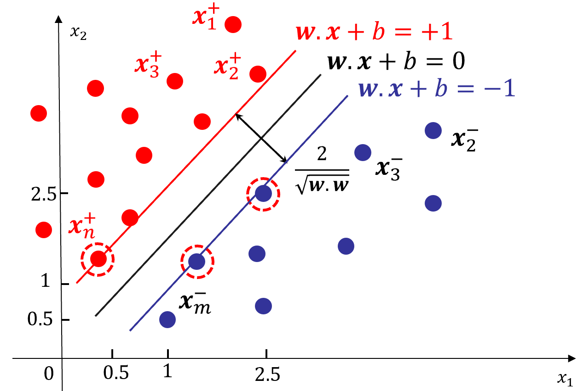
Feature based sentiment analysis include feature extraction, sentiment prediction, sentiment classification.

Feature Extraction:
Feature extraction identifies those product aspects which are being commented by users opinion by deciding sentiment polarity as positive, negative or neutral. It is advantageous to reduce the number of input features to Support Vector Machine in order to get efficient results. To reduce feature set, the aim is to select only the useful features from the entire set of features.

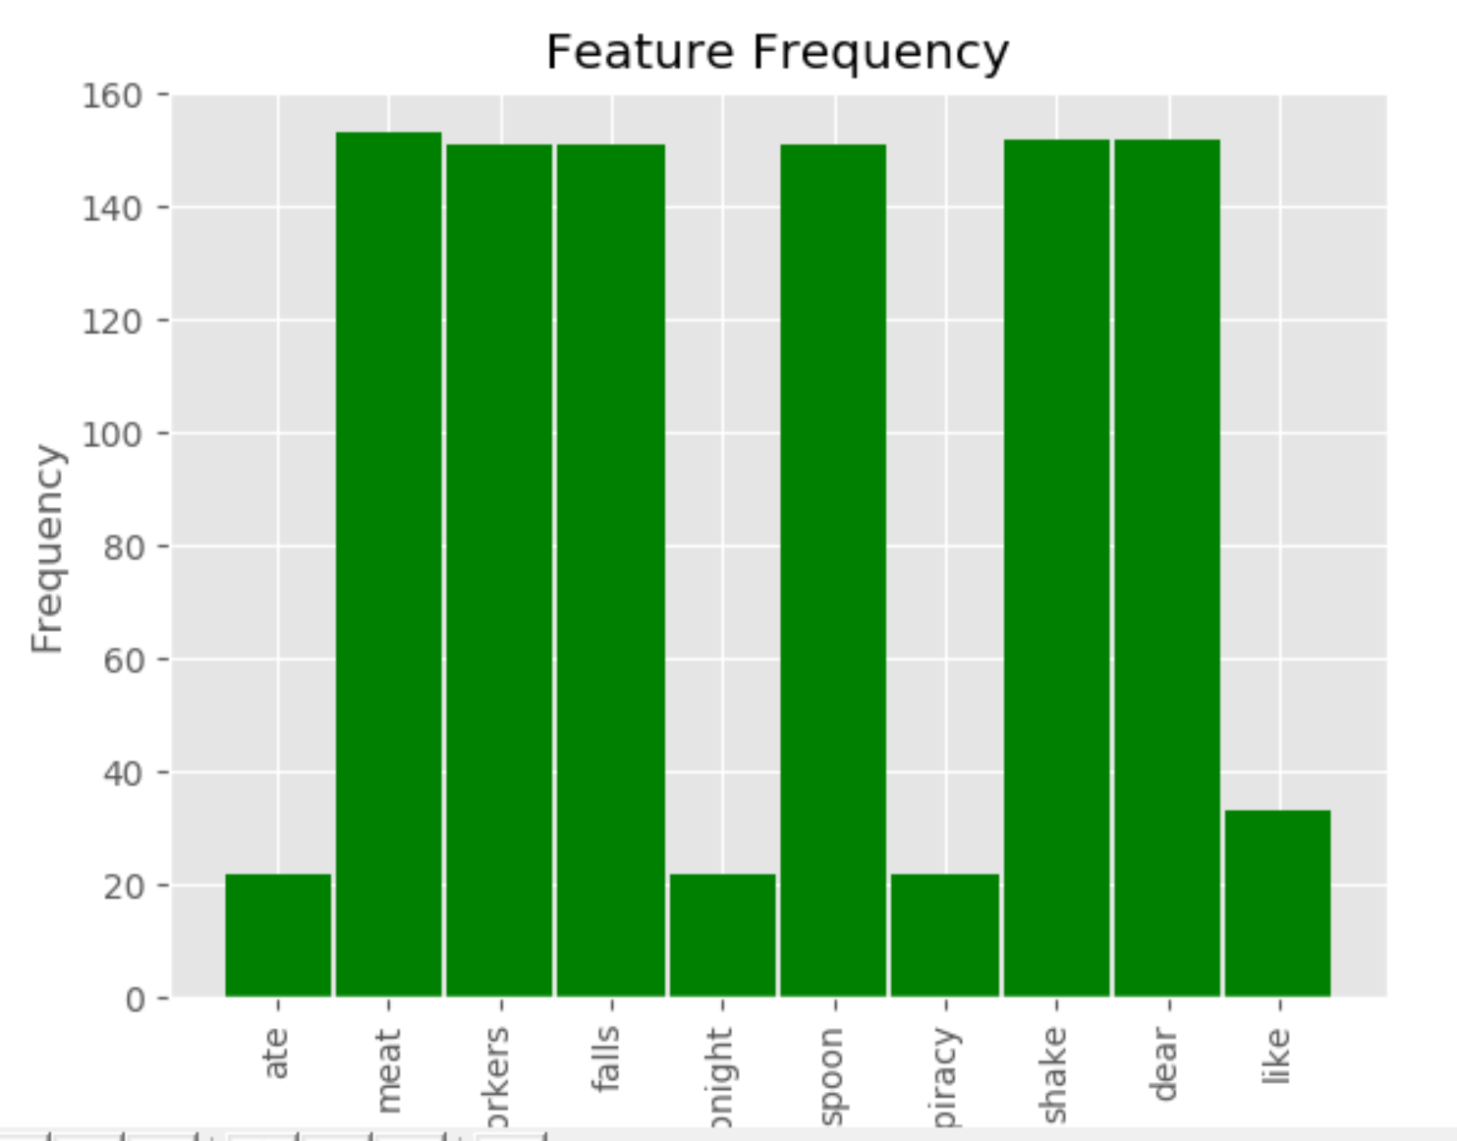
Feature Frequency for Food Classifier
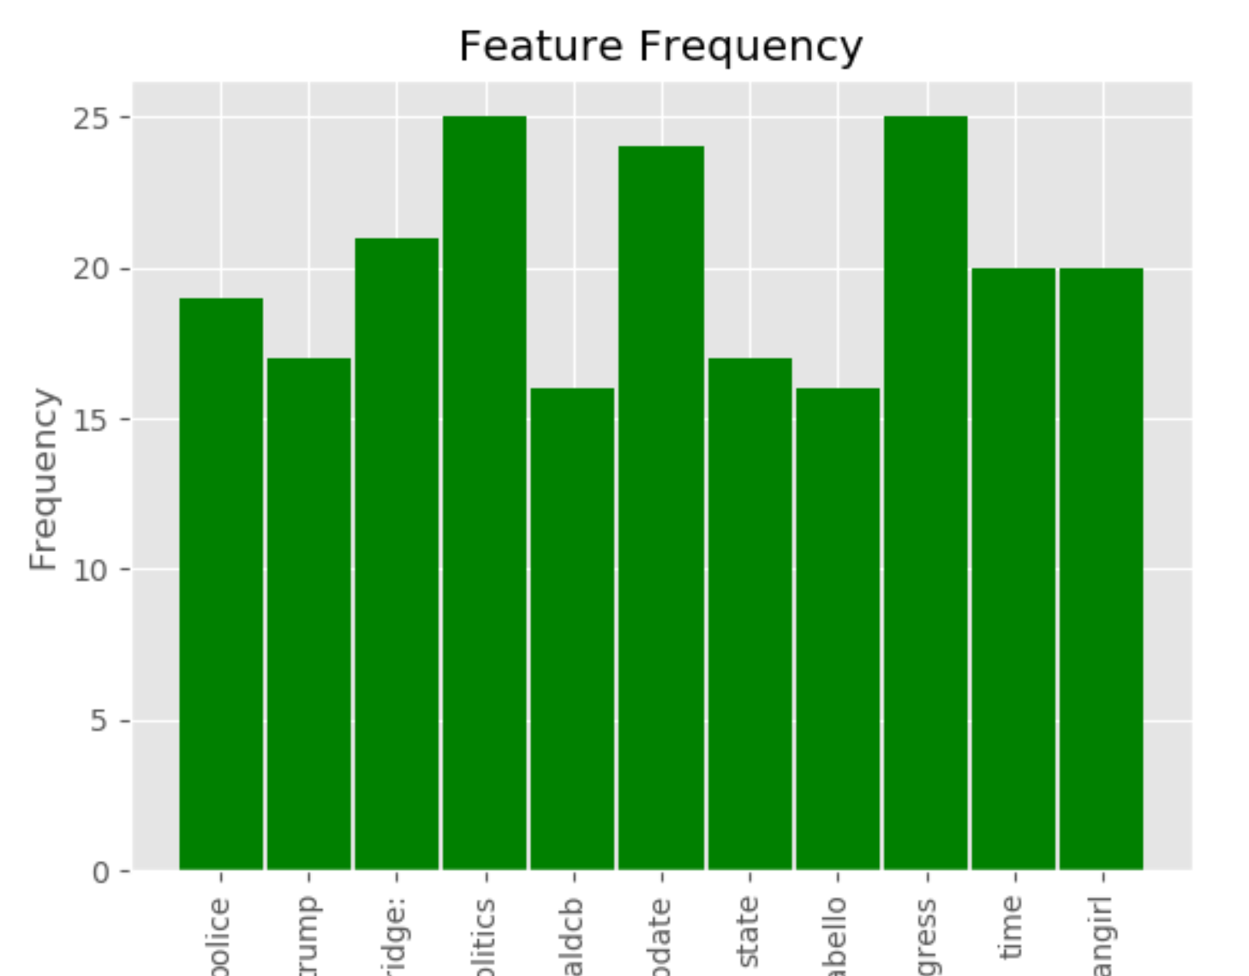
Feature Frequency for Politic Classifier

10 folder validation:

Cross-validation is a statistical method used to estimate the skill of machine learning models.
The procedure has a single parameter called k that refers to the number of groups that a given data sample is to be split into. As such, the procedure is often called k-fold cross-validation. When a specific value for k is chosen, it may be used in place of k in the reference to the model, such as k=10 becoming 10-fold cross-validation [5].
Cross-validation is used to estimate the skill of a the classifier build on new data set. That is, to use a limited data set in order to estimate how the model is expected to perform in general when used to make predictions on data not used during the training of the model.
We found that results are less biased or less optimistic estimate of the model skill than other methods, such as a simple train/test split.

10 folder validation estimation for the Food Classifier:
The estimated w:
[[-1.0000e+00 -4.9984e-01 -4.9984e-01 -4.9984e-01 -1.0000e+00 -4.9984e-01 -2.0000e+00 -6.4000e-04 0.0000e+00 0.0000e+00]]

The estimated b: [1.00016]

The estimated C after the grid search for 10 fold cross validation: {'C': 1}

10 folder validation estimation for the Politics Classifier:

The estimated w:
[[ 1.99861453e+00 -6.36011666e-04 1.49957072e+00 -4.29275250e-04 0.00000000e+00 4.99570725e-01 -1.21206875e-03 -1.15211416e-03 -4.29275250e-04 -1.33675303e-03 1.99898987e+00]]

The estimated b: [-0.99889509]
The estimated C after the grid search for 10 fold cross validation: {'C': 1}

Integration with Web
To integrate with the web, Flask web framework is used send HTTP request to the classifiers based on the input provided by the user on the web page.

Flask:
Flask is a Python web development microframework. It is classified as a microframework because it does not require particular tools or libraries.
Instead, Flask supports extensions to add such functionality to your application as if it was implemented in Flask itself

Code Snippet:

app = Flask(__name__)
@app.route("/")
def home():
return render_template('home.html')
@app.route("/index")
@app.route('/trend', methods=['GET', 'POST'])
def trend():

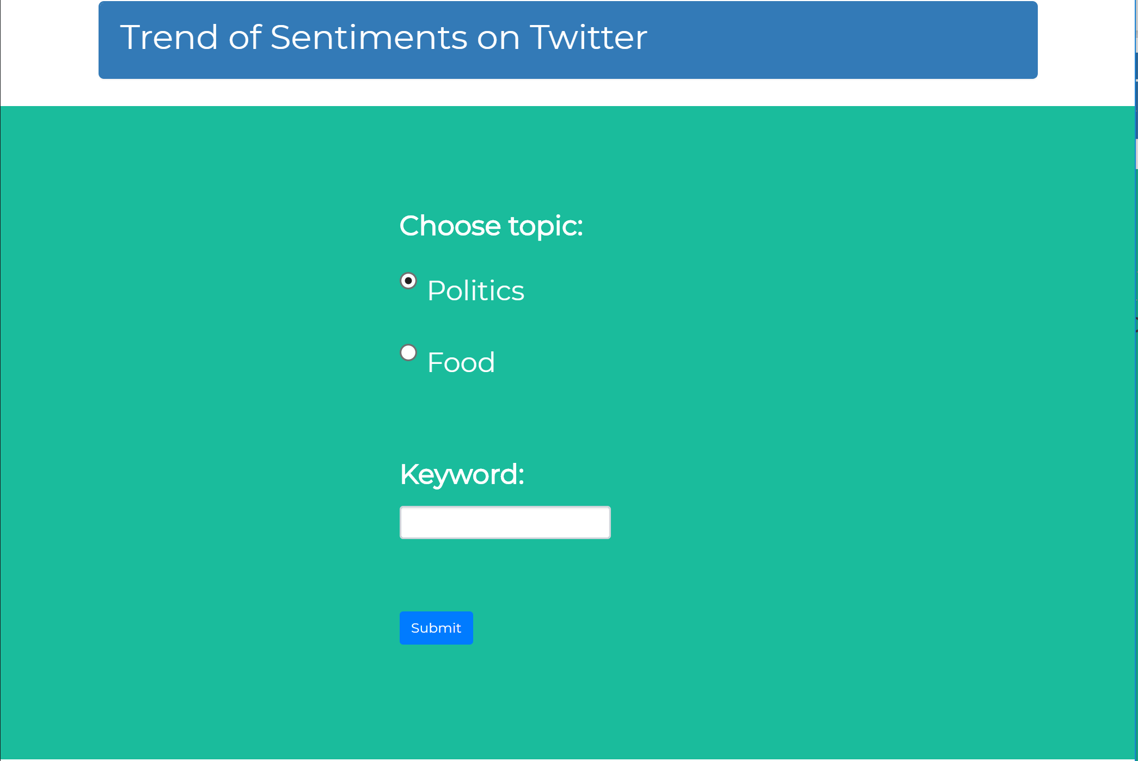

HTML page for user to select topic and keyword

Results

Results are saved in text files and also displayed to the used using pie chart which provides the convenient and easy interpretation for the users.

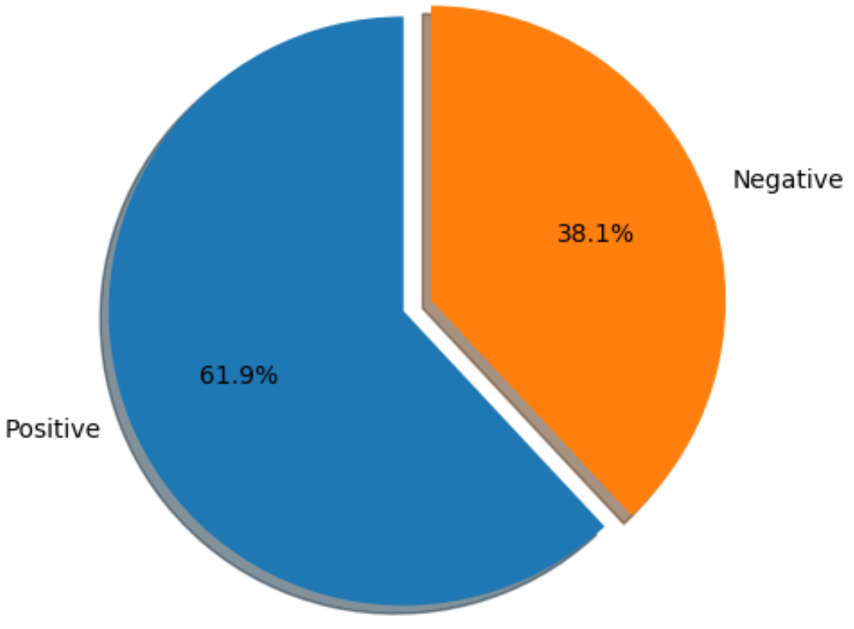
Result pie chart for Food Classifier

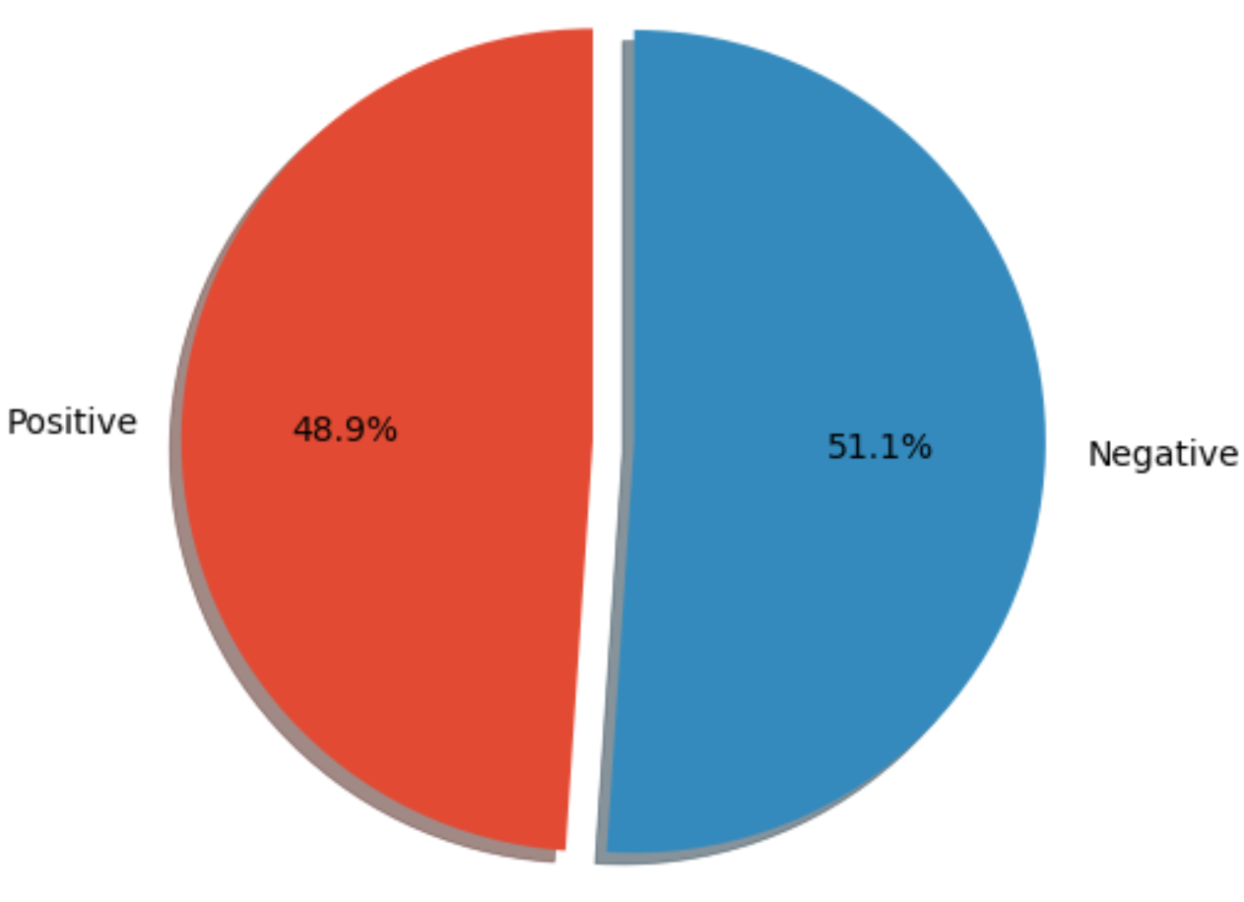

Pie chart for Politics Classifier

Conclusion
Based on our experiments, we conclude that Sentiment Analysis is an effective way to determine the people's opinion towards specific topic, item or entity. As social media is indeed a platform where a vast population share their opinion and information is propagated to make an impact.

limitation
Although the design provide the scope to extend the functionality beyond the two topic for which the model is trained but at this moment this ca only work for these two topics unlike the others where polarity is determined based on pre-defined list for positive, negative and neutral words but not specific to the topic.

future work
As mentioned above that the design provide the scope to extend this project in future to different topic so that user can see sentiment analysis for major topics instead of just two

Acknowledgments
The author would like to thank Professor Chen for providing his guidance and support for this project work

references
[1] User’s Guide to Support Vector Machines by Asa Ben-Hur and Jason Weston
https://www.researchgate.net/publication/41896604_A_User's_Guide_to_Support_Vector_Machines
[2] An Idiot’s guide to Support vector machines (SVMs) by R. Berwick, Village Idiot
http://web.mit.edu/6.034/wwwbob/svm.pdf
[3] https://link.springer.com/chapter/10.1007/978-3-642-17534-3_14
[4] Feature Extraction Techniques Using Support Vector Machines in Disease Prediction - Sandeep Kaur, Dr. Sheetal Kalra
https://pdfs.semanticscholar.org/3c77/d10b16f5e3d5dc3cf0bbd2817c966479f698.pdf
[5] A Gentle Introduction to k-fold Cross-Validation - Jason Brownlee
https://machinelearningmastery.com/k-fold-cross-validation/
[6] https://www.analyticsvidhya.com/blog/2017/09/understain g-support-vector-machine-example-code/

